BASKETBALL

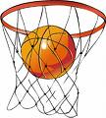

TIME | 01.04.2014  ( Tuesday ) | 02.04.2014 (Wednesday) | 03.04.2014  ( Thursday )
16:00 | VFU - NA | VFU - TU | MU - TU
17:00 | TU - UE | NA - UE | UE - VFU
18:00 | NA -MU | MU - VFU | TU - NA
19:00 |  |  | MU - UE

BOWLING
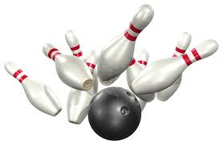
DATE | TIME | LOCATION
01-04.04.2014 | 15:00 | “Playground” Sports Bar - Varna Mall, 4th floor

LONG-DISTANCE RACE

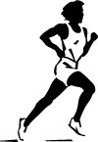

DATE | TIME | LOCATION
05.04.2014  ( Saturday ) | 11:00 | Sea Garden,  Summer Theatre

TENNIS
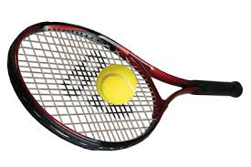
DATE | TIME | LOCATION
05.04.2014  ( Saturday ) | 09:00 | Open tennis courts at Chaika Tennis Complex - Teams
06.04.2014  (Sunday) | 09:00 | Open tennis courts at Chaika Tennis Complex - Singles

VOLLEYBALL
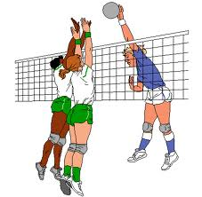

TIME | 07.04.2014  ( Monday ) | 08.04.2014  ( Tuesday ) |  | 09.04.2014  ( Wednesday )
15:00 | VFU – NA  (men) | 15:00 | VFU – MU  ( men) | 14:00 | NA – VFU  (women)
16:30 | UE – MU  (men) | 16:30 | UE – VFU  (women) | 15:30 | NA – UE  (men)
18:00 | UE – NA  (women)

TIME | 10.04.2014  ( Thursday)
14:00 | NA – MU  (men)
15:30 | UE – VFU  (men)

FOOTBALL
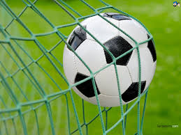

First Day – 07.04.2014 (Monday) TU
TIME | FIRST PITCH | SECOND PITCH
17:00 | - | NA ₂ – UE₂
18:00 | UE ₁ – VFU ₁ | TU ₂ – MU ₂
19:00 | TU ₁ – MU ₁ | NA ₂ – VFU ₂
20:00 | NA ₁ – VFU ₁ | UE ₂ – TU ₂

Second Day – 08.04.2014 (Tuesday) TU
TIME | FIRST PITCH | SECOND PITCH
17:00 | UE ₁ – TU ₁ | NA ₂ – MU ₂
18:00 | NA ₁ – MU ₁ | UE ₂ – VFU ₂
19:00 | TU ₁ – VFU ₁ | -
20:00 | NA ₁ – UE ₁ | MU ₂ – VFU ₂

Third Day – 10.04.2014 (Thursday) TU
TIME | FIRST PITCH | SECOND PITCH
17:00 | UE₁ – MU ₁ | TU ₂ – VFU ₂
18:00 | NA ₁ – TU ₁ | UE ₂ – MU ₂
19:00 | MU ₁ – VFU ₁ | NA ₂ – TU ₂

Fourth Day – 11.04.2014 (Friday) TU
TIME | FIRST PITCH | SECOND PITCH
17:00 | First А – Second В | Second А – First В
18:00 | МATCH FOR THE THIRD AND FOURTH PLACE
19:00 | FINAL

TABLE TENNIS
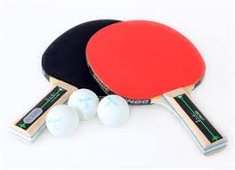

DATE | TIME | LOCATION
10.04.2014  (Thursday) | 15:00 | University of Economics

CHESS
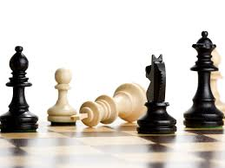
DATE | TIME | LOCATION
11.04.2014  (Friday) | 13:00 | Mladezhki Dom (Youth Centre), Hall 12

SWIMMING

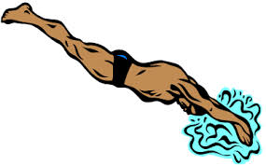
DATE | TIME | LOCATION
12.04.2014  (Saturday) | 10:30 | «Primorski» Swimming Complex

