 | MEDICAL UNIVERSITY – VARNA  “Prof. Dr. Paraskev Stoyanov”  55, Marin Drinov Str., 9002 Varna, Bulgaria  Tel.: +359 52/ 65 00 57, Fax: +359 52/ 65 00 19  e-mail: uni@mu-varna.bg, www.mu-varna.bg | 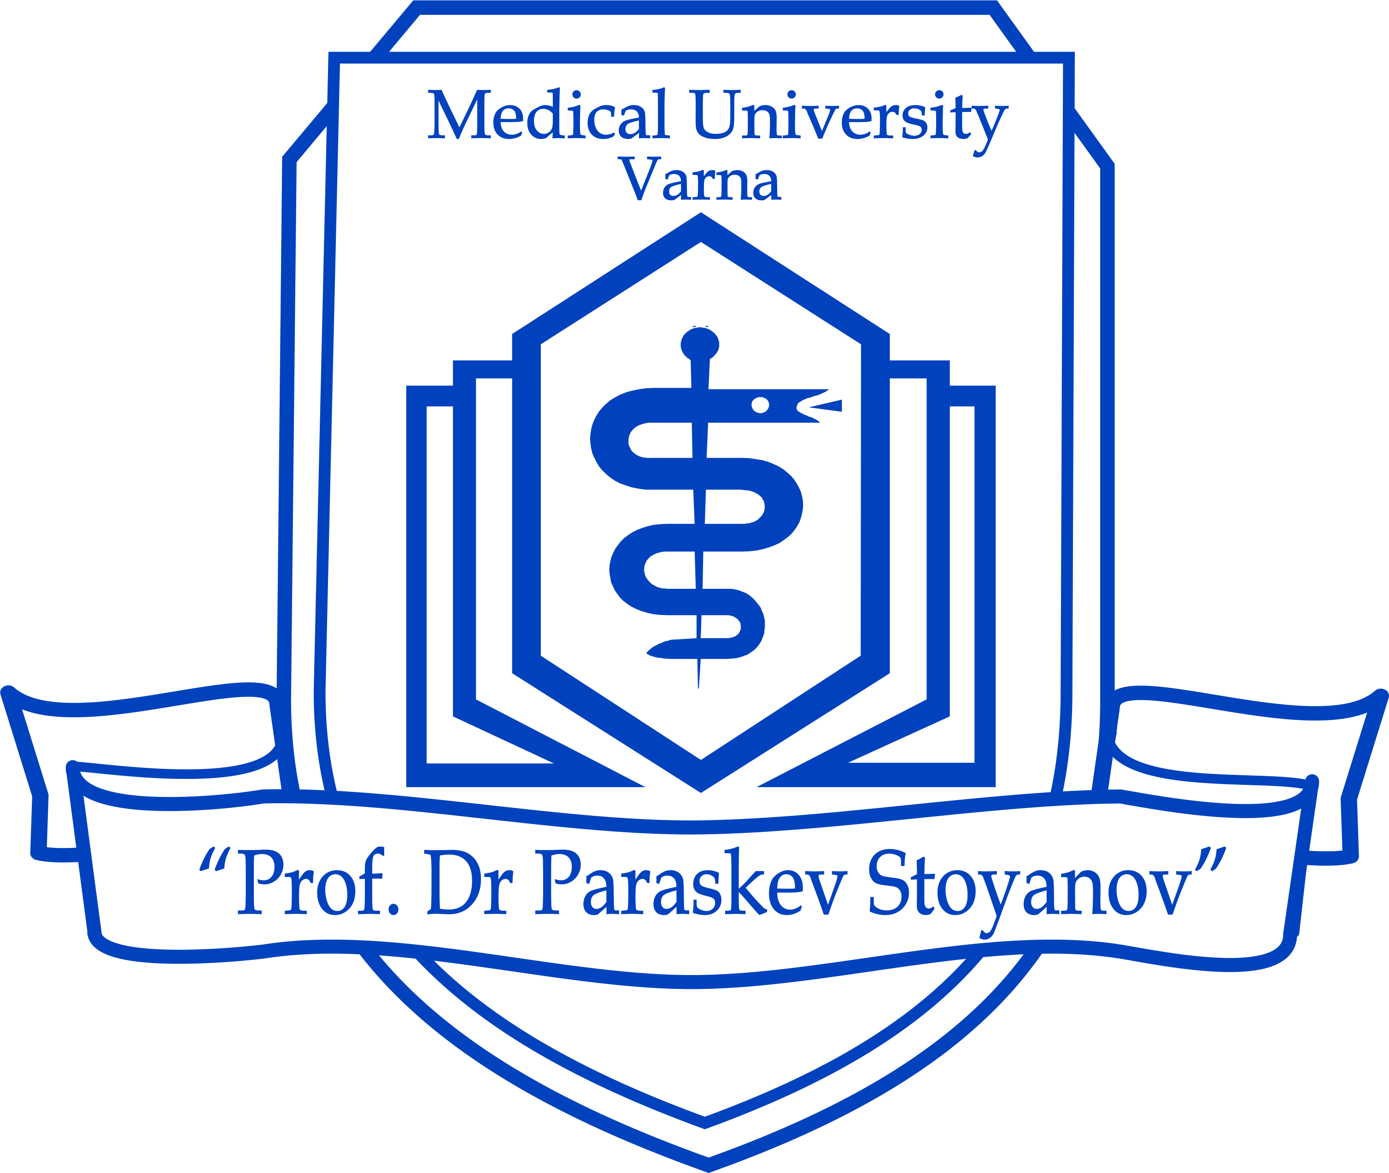

Medical University – Varna
offers the following opportunities for Erasmus internships
during the next academic year 2016/2017:

Erasmus pre-graduate state internship during the 6th year of academic studies
State | City | University |  |  | Number of mobilities | Traineeship duration (months) |  | Language of instruction
Belgium | Bruxelles | Université Libre de Bruxelles |  |  | 2 | 3 - 9 |  | French
Germany | Dresden | Technische Universität Dresden |  |  | 2 | 3 - 9 |  | German
 | Köln | Universität zu Köln |  |  | 3 | 3 - 9 |  | German
 | Magdeburg | Otto-von-Guericke-Universität Magdeburg |  |  | 2 | 3 - 9 |  | German
 | Rostock | Universität Rostock |  |  | 2 | 3 - 9 |  | German
 | Tuebingen | Eberhard Karls Universität Tuebingen |  |  | 1 | 3 - 9 |  | German
Italy | Bari | University Of Bari Aldo Moro |  |  | 3 | 3 - 9 |  | English
Poland | Wroclaw | Wroclaw Medical University |  |  | 1 | 3 - 9 |  | English
 | Katowice | Medical University of Silesia |  |  | 2 | 3 - 9 |  | English
Turkey | Isparta | Süleyman Demirel University |  |  | 3 | 3 - 9 |  | Turkish or  English
 | Edirne | Trakya University |  |  | 3 | 3 - 9 |  | Turkish or English
 | Izmir | Ege University |  |  | 2 | 3 - 9 |  | Turkish or English
 | Istanbul | University of Istanbul |  |  | 2 | 3 - 9 |  | Turkish or English
Hungary | Szeged | University of Szeged |  |  | 2 | 3 - 9 |  | English
France | Bordeaux | Université De Bordeaux Victor Segalen |  |  | 3 | 3 - 9  (Surg, IntMed) |  | French
Czech Republic | Hradec Kralove | Charles University in Prague |  |  | 2 | 3 - 9 |  | Czech
Erasmus summer internship after the 3rd or 4th year of academic studies
State | City | University |  | Number of mobilities |  |  | Traineeship duration (months) | Language of instruction
Germany | Dresden | Technische Universität Dresden | 2 |  |  |  | 2 | German
 | Rostock | Universität Rostock | 5 |  |  |  | 2 | German
Italy | Bari | University Of Bari  Aldo Moro | 3 |  |  |  | 2 | English
Poland | Warsaw | Medical University of Warsaw | 2 |  |  |  | 2 | English
 | Wroclaw | Wroclaw Medical University | 5 |  |  |  | 2 | English
 | Katowice | Medical University of Silesia | 2 |  |  |  | 2 | English
Turkey | Isparta | Süleyman Demirel University | 3 |  |  |  | 2 | Turkish or English
 | Edirne | Trakya University | 3 |  |  |  | 2 | Turkish or English
 | Istanbul | University of Istanbul | 2 |  |  |  | 2 | Turkish or English
Hungary | Szeged | University of Szeged | 2 |  |  |  | 2 | English
Czech Republic | Hradec Kralove | Charles University in Prague | 2 |  |  |  | 2 | Czech

The applicants should have an average grade (GPA) as of the time of application minimum 4.50.
The applicants must have taken all their exams till the time of application.

