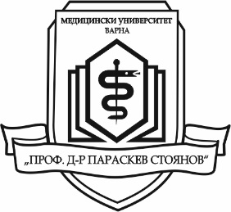
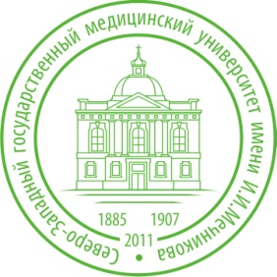

SUMER PRACTICE FOR
POSTGRADUATE STUDENTS

in the North Western State Medical University
“I. I. Mechniokv”
in SAINT PETERSBURG, RUSSIA

Summer practice for postgraduate students
of Medical University “Prof. Dr. Paraskev Stoyanov” – Varna
will be carried out in Saint Petersburg, Russia
from 1st until 14th of August 2016

Documents can be submitted in the period:
February 16th – March 9th 2016

Dormitory, breakfast and lunch - provided by the University
Airplane tickets and daily costs - covered by the candidates

Criteria for the selection of students:
Compulsory:
1. To have a minimum average grade from the Diploma – Very Good 4.50;
2. Good command of Russian language is an advantage.
Additional:
To have interests in one of the following areas: sport, music, dances and social activities

A special commission will select the best two candidates
until March 21st 2016
The approved candidates will be informed by е-mail or telephone.

Documents:
1. The application must contain information about the desired areas of the practice (preferably more than one). The application is addressed to Prof. Todorka Kostadinova, PhD, Vice Rector for International Relations, Accreditation and Quality
2. CV (with contact information)
3. Certificate of proficiency of Russian language, if applicable
4. Copy of the Diploma
Submission of documents: in the Department of International Relations, Main university building, 2nd floor, room 209, Tel.: +359 52 677109, e-mail: international_relations@mu-varna.bg

